

Project Interim Report

On
Contact Directory Management (OOP Project)
RU-100-01-00012
Object Oriented Programming with Java

SESSION: 2025-26

Submitted By
Apeksha Thawkar
RU-25-11808

Bachelor of Technology in Computer Science & Engineering with Data Science in association with Google

Under the Guidance of MrAshish Shivhare
IBM SME and EXPERT

SCHOOL OF COMPUTER SCIENCE AND ENGINEERING RUNGTA INTERNATIONAL SKILLS UNIVERSITY
BHILAI, CG

(April 2026)

Abstract
The Contact Directory Management System is a Java-based application developed using Object-Oriented Programming concepts. The system helps users store and manage personal or professional contact information efficiently. It allows users to add, search, delete, and display contacts through a simple interface.
Managing contacts manually can be time-consuming and error-prone. This project provides an organized method to maintain contact records using classes, arrays, and object encapsulation. The Contact class stores individual contact information such as name and phone number, while the Directory class manages multiple contacts.
The project demonstrates the practical implementation of OOP concepts such as classes, objects, constructors, encapsulation, and array manipulation. It also implements searching and deletion algorithms to handle contact records effectively. This system serves as a real-world application of Java programming fundamentals and can be extended further with database support and graphical user interfaces.

Introduction

In today's digital world, maintaining contact information efficiently is essential for both personal and professional communication. A Contact Directory Management System is designed to store and organize contact details in a structured manner.

This project is developed using Java and Object-Oriented Programming principles. The system stores contact names and phone numbers and provides functionalities such as adding new contacts, searching for existing contacts, deleting contacts, and displaying all saved contacts.

The application uses a Contact class to represent individual contacts and a Directory class to manage multiple contact records. Through this project, students gain practical experience in class design, object management, searching techniques, and array operations.

Features

Add new contacts

Search contacts by name

Delete contacts

Display all contacts

Case-insensitive search

Array-based storage management

User-friendly output

Scope
The Contact Directory Management System is suitable for managing a small number of contacts in personal or educational environments.
The project can be extended in the future by:
- Using databases for permanent storage.
- Adding email and address fields.
- Implementing contact update functionality.
- Developing a graphical user interface (GUI).
- Integrating cloud-based storage systems.

System Requirements
Hardware Requirements
- Computer/Laptop
- Minimum 4 GB RAM
- Intel i3 Processor or higher
Software Requirements
- Java JDK 8 or above
- Eclipse IDE / VS Code / IntelliJ IDEA
- Windows/Linux Operating System

Methodology
The project follows the following sequence:
Step 1
Create a Contact object containing name and phone number.
Step 2
Store contacts in an array maintained by the Directory class.
Step 3
Add new contacts using the addContact() method.
Step 4
Search contacts using the searchContact() method with case-insensitive comparison.
Step 5
Delete contacts using the deleteContact() method.
Step 6
Shift array elements after deletion to maintain data consistency.
Step 7
Display all available contacts.

Flowchart
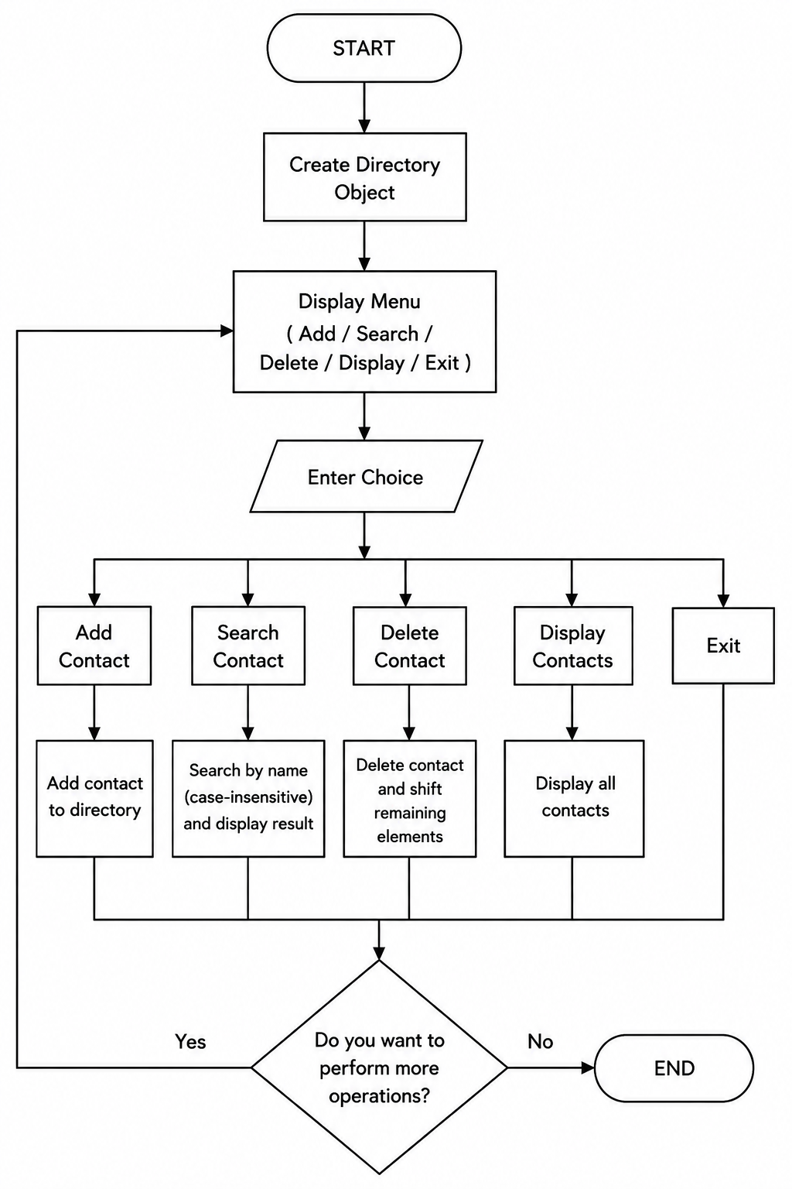

Implementation
Contact Class
The Contact class represents an individual contact. It stores:
- Contact Name
- Phone Number
The class uses constructors to initialize values and getter methods to retrieve data.
Functions
- Constructor
- getName()
- getPhone()

Directory Class
The Directory class manages all contacts stored in the system.
Variables
- Contact[] contacts
- int count
Methods
addContact()
Adds a new contact to the next available position in the array.
searchContact()
Searches for a contact by name using equalsIgnoreCase().
deleteContact()
Finds the contact and removes it by shifting remaining array elements.
displayContacts()
Displays all available contacts in the directory.

Sample Input/Output
Adding Contact
Contact added successfully
Searching Contact
Searching for: Rahul
Name: Rahul
Phone: 9876543210
Deleting Contact
Deleting Rahul...
Contact deleted successfully
Searching Again
Searching for: Rahul
Contact not found

Future Enhancements
- Database integration using MySQL.
- GUI implementation using Java Swing or JavaFX.
- Contact update feature.
- Email management support.
- Backup and restore functionality.
- Cloud synchronization.
- Password-protected direct

Grantt Graph

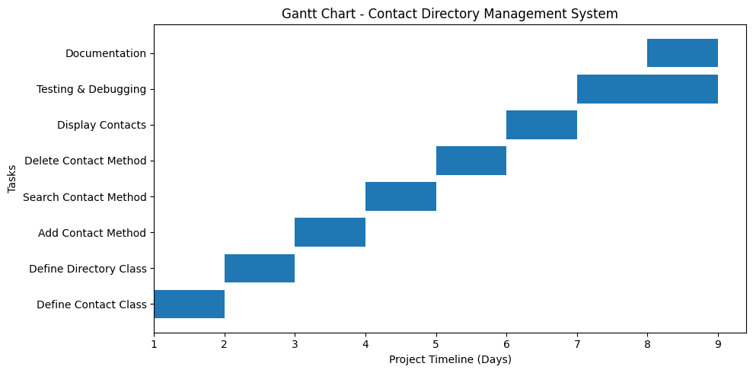

Conclusion
The Contact Directory Management System successfully demonstrates the implementation of Object-Oriented Programming concepts using Java. The project provides a simple and effective way to manage contacts by allowing users to add, search, delete, and display contact information.
The project enhances understanding of classes, objects, encapsulation, arrays, searching techniques, and deletion operations. It serves as a strong foundation for developing larger management systems in the future.

References Book Format:
[1] Author(s), *Book Title*, Edition. City: Publisher, Year.

Example:
[1] H. Schildt, *Java: The Complete Reference*, 11th ed. New York: McGraw-Hill, 2018.

Website Format:
[2] Author (if any), "Title of page," Website Name. [Online]. Available: URL

Example:
[2] Oracle, "Java Documentation," Oracle. [Online]. Available: https://docs.oracle.com

Conference Paper
Format:
[3] Author(s), "Paper title," in Proc. Conference Name, year, pp.
Example:
[3] S. Kumar, "AI in Education," in Proc. IEEE Conf. on AI, 2021, pp. 120-125.

Journal Article
Format:
[4] Author(s), "Title of paper," Journal Name, vol., no., pp., year.
Example:
[4] A. Sharma and R. Gupta, "Machine Learning Techniques," International Journal of AI, vol. 5,
no. 2, pp. 45-50, 2020.

